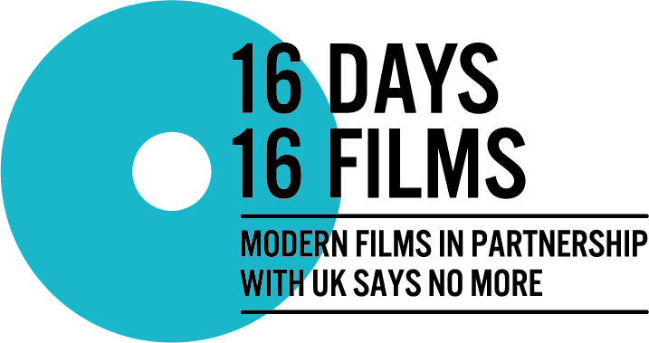

ENTRIES NOW OPEN FOR UK FEMALE FILM MAKERS TO END GENDER- BASED VIOLENCE IN THE WORKPLACE.
MODERN FILMS JOINS UK SAYS NO MORE FOR 16 DAYS OF ACTIVISM COMPETITION.

Modern Films in partnership with UK SAYS NO MORE, a national campaign facilitated by London charity Hestia to end domestic abuse and sexual violence, is holding an open call to female filmmakers in the UK to submit short films inspired by 16 Days of Activism against Gender based Violence’s 2018 theme ‘End Gender-Based Violence in the World of Work.’

The competition will showcase 16 films to be selected by a nomination panel of industry experts with one film being released online each day during 16 Days of Activism. The final day will host a special screening of all 16 films at a central London on Tuesday December 11th, with one winning filmmaker and two runners up receiving a prize and the winner also receiving the opportunity to create the new UK SAYS NO MORE public service announcement.

Films should be up to 5 minutes long and can be any genre. The films should explore the theme: ‘End Gender-Based Violence in the World of Work’.

For many people, domestic abuse and sexual violence are often difficult subjects to talk about, despite an estimated 4.5 million women and 2.2 million men experiencing domestic abuse since the age of 16, and 50% of women experiencing sexual harassment in the workplace in England and Wales each year (ONS).

We recognise that domestic abuse and sexual violence is not a female only issue. We are holding an open call to female filmmakers in our first year to help address the gender imbalance in the film industry by actively encouraging and supporting female directors and writers in film.

Sarah Winterflood, Partnership Manager at UK SAYS NO MORE, Hestia said:
‘Film is a platform that can be used to create real social change. We are especially grateful to have the support of Modern Films to highlight the impact and effect of domestic abuse and sexual violence. These issues are still considered taboo subjects and these films are a great way to start the conversation and highlight the support available.’

Johanna von Fischer, Audience Development at MODERN FILMS said: “At Modern Films we believe in supporting content that addresses the pressing social issues of our times. We want to support the conversation and be a part of the change by giving filmmakers a platform to have a voice and share their stories. We believe a competition like this, that gives a working opportunity to a new or emerging filmmaker, might help give her the confidence and profile to take next steps and further develop her career”

For further information, please visit:
http://uksaysnomore.org/campaign/16daysfilmcompetition/

Contacts:
Josh Mclean | josh.mclean@hestia.org | 020 7378 3160 | 07845 555995

Johanna von Fischer | johanna@modernfilms.com | 07790 153772

About 16 Days of Activism
16 Days of Activism Against Gender-Based Violence is an International campaign to challenge gender violence. The campaign runs every year from 25th November, The International Day for the Elimination of Violence against Women, to 10th December, International Human Rights Day. Every year, the campaign adopts a new theme. The theme focuses on one particular area of gender inequality and works to bring attention to these issues and makes changes that will have an impact. This year’s theme is ‘End Gender-Based Violence in the World of Work.’

About UK SAYS NO MORE
UK SAYS NO MORE is a nationwide campaign to raise awareness to end Sexual Violence and Domestic Abuse. The campaign is a partnership between London-based charity Hestia and NO MORE in the United States. The UK SAYS NO MORE campaign brings together practitioners in the field of domestic violence and sexual assault, corporate partners, celebrities and members of the general public. The campaign seeks to raise visibility, create awareness, encourage conversation, and help break the social stigma surrounding Sexual Violence and Domestic Abuse.
Website: www.uksaysnomore.org
Follow @UKSAYSNOMORE for updates on Facebook, Twitter and Instagram.

About MODERN FILMS
Modern Films is a London-based, female-led film production, distribution and event cinema company, working with rising and established talent from around the world and bringing innovative stories to global audiences. We focus on creating connections between content, context and curation, with a particular emphasis on pressing social issues of our time expressed through the power of cinema and cultural expression.
Website: www.modernfilms.com
Follow @MODERNFILMSENT on Twitter, Instagram and Modern Films on Facebook.

About Hestia
At Hestia, we support adults and children across London in times of crisis. Last year we worked with more than 9,000 people including women and children who have experienced domestic abuse, victims of modern slavery, young care leavers and older people. From giving someone a home to helping them to get the right mental health support, we support and enable people at the moment of crisis.

Hestia is the largest provider of domestic abuse refuges in London and last year we supported 3,657 people to recover from the trauma of domestic abuse including 668 children. We provide families refuge accommodation, dedicated children and family support, IDVA (Independent Domestic Abuse Advocates) and MARAC (Multi-Agency Risk Assessment Centre) support and community group support.

